**ASSIGNMENT-2**

**EC2- Classic Load Balancer**

* Create 2 Ec2 windows free tier instances.
* Configure IIS server on both. Be sure you are configuring them on two different availability zones for achieving high availability.
* Configuring a classic load balancer between those two instances with HTTP service port.

Note: You can use one node same from Assignment 1 of IIS server.

**Load Balancing-**

Load Balancing distributes incoming application or network traffic across multiple targets, such as Amazon EC2 instances, containers, and IP addresses, in multiple Availability Zones. Elastic Load Balancing scales your load balancer as traffic to your application changes over time. It can automatically scale to the vast majority of workloads.

**Load Balancer Benefits-**

A load balancer distributes workloads across multiple compute resources, such as virtual servers. Using a load balancer increases the availability and fault tolerance of your applications.

You can add and remove compute resources from your load balancer as your needs change, without disrupting the overall flow of requests to your applications.

You can configure health checks, which monitor the health of the compute resources, so that the load balancer sends requests only to the healthy ones. You can also offload the work of encryption and decryption to your load balancer so that your compute resources can focus on their main work.

Elastic Load Balancing supports three types of load balancers: Application Load Balancers, Network Load Balancers, and Classic Load Balancers. Here we’ll discuss Classic Load Balancers.

**Classic Load Balancer-**

A load balancer distributes incoming application traffic across multiple EC2 instances in multiple Availability Zones. This increases the fault tolerance of your applications. Elastic Load Balancing detects unhealthy instances and routes traffic only to healthy instances.

Your load balancer serves as a single point of contact for clients. This increases the availability of your application. You can add and remove instances from your load balancer as your needs change, without disrupting the overall flow of requests to your application. Elastic Load Balancing scales your load balancer as traffic to your application changes over time. Elastic Load Balancing can scale to the vast majority of workloads automatically.

You can configure health checks, which are used to monitor the health of the registered instances so that the load balancer only sends requests to the healthy instances.

**Steps:**

1. Create two EC2 windows free tier instances. i.e. Windows Server 1 and Windows Server 2
2. Configure on two different availability zones. i.e. us-east-2a and us-east-2b

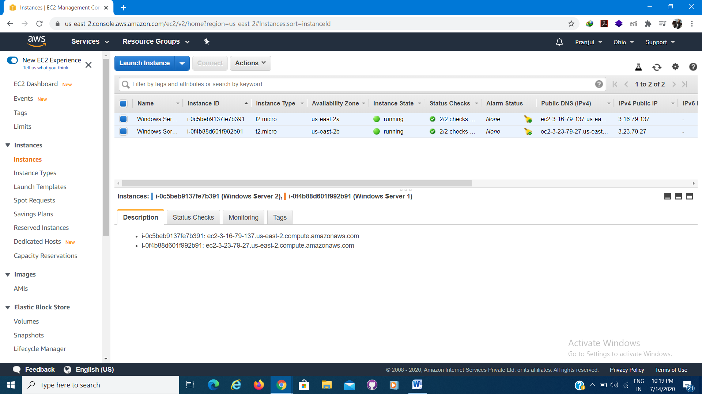

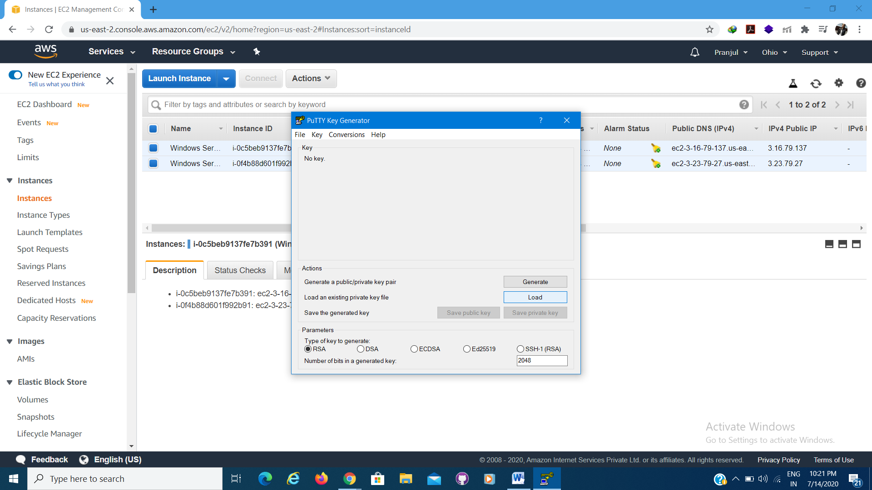

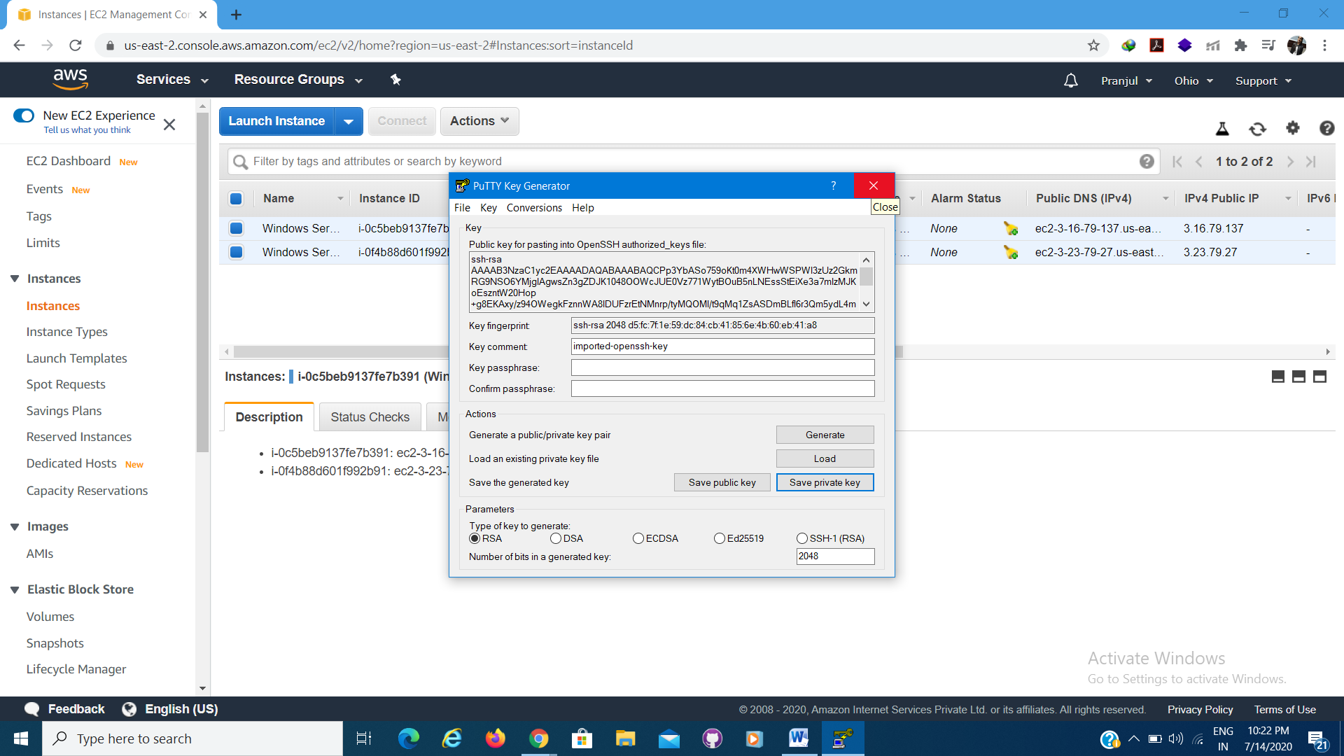

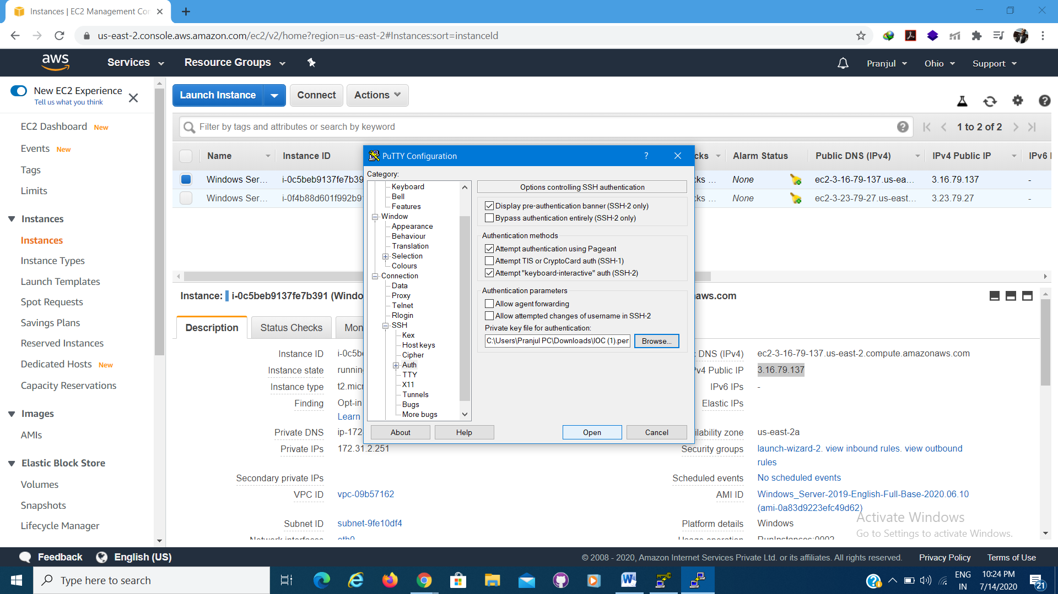

Two Windows Server (IIS) are launched.

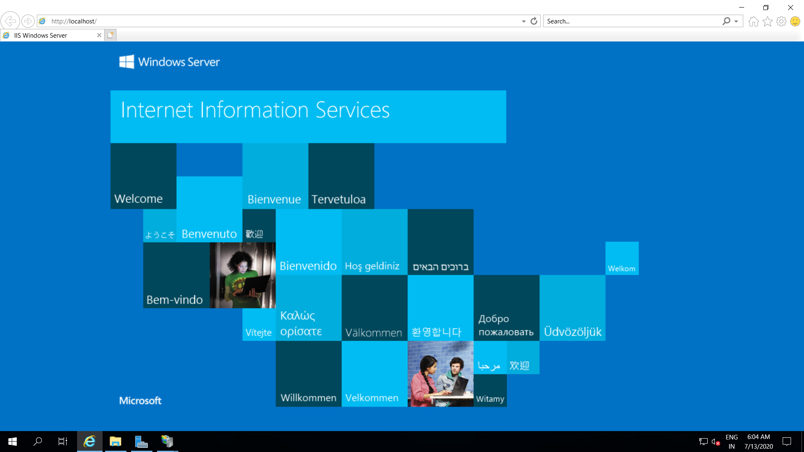

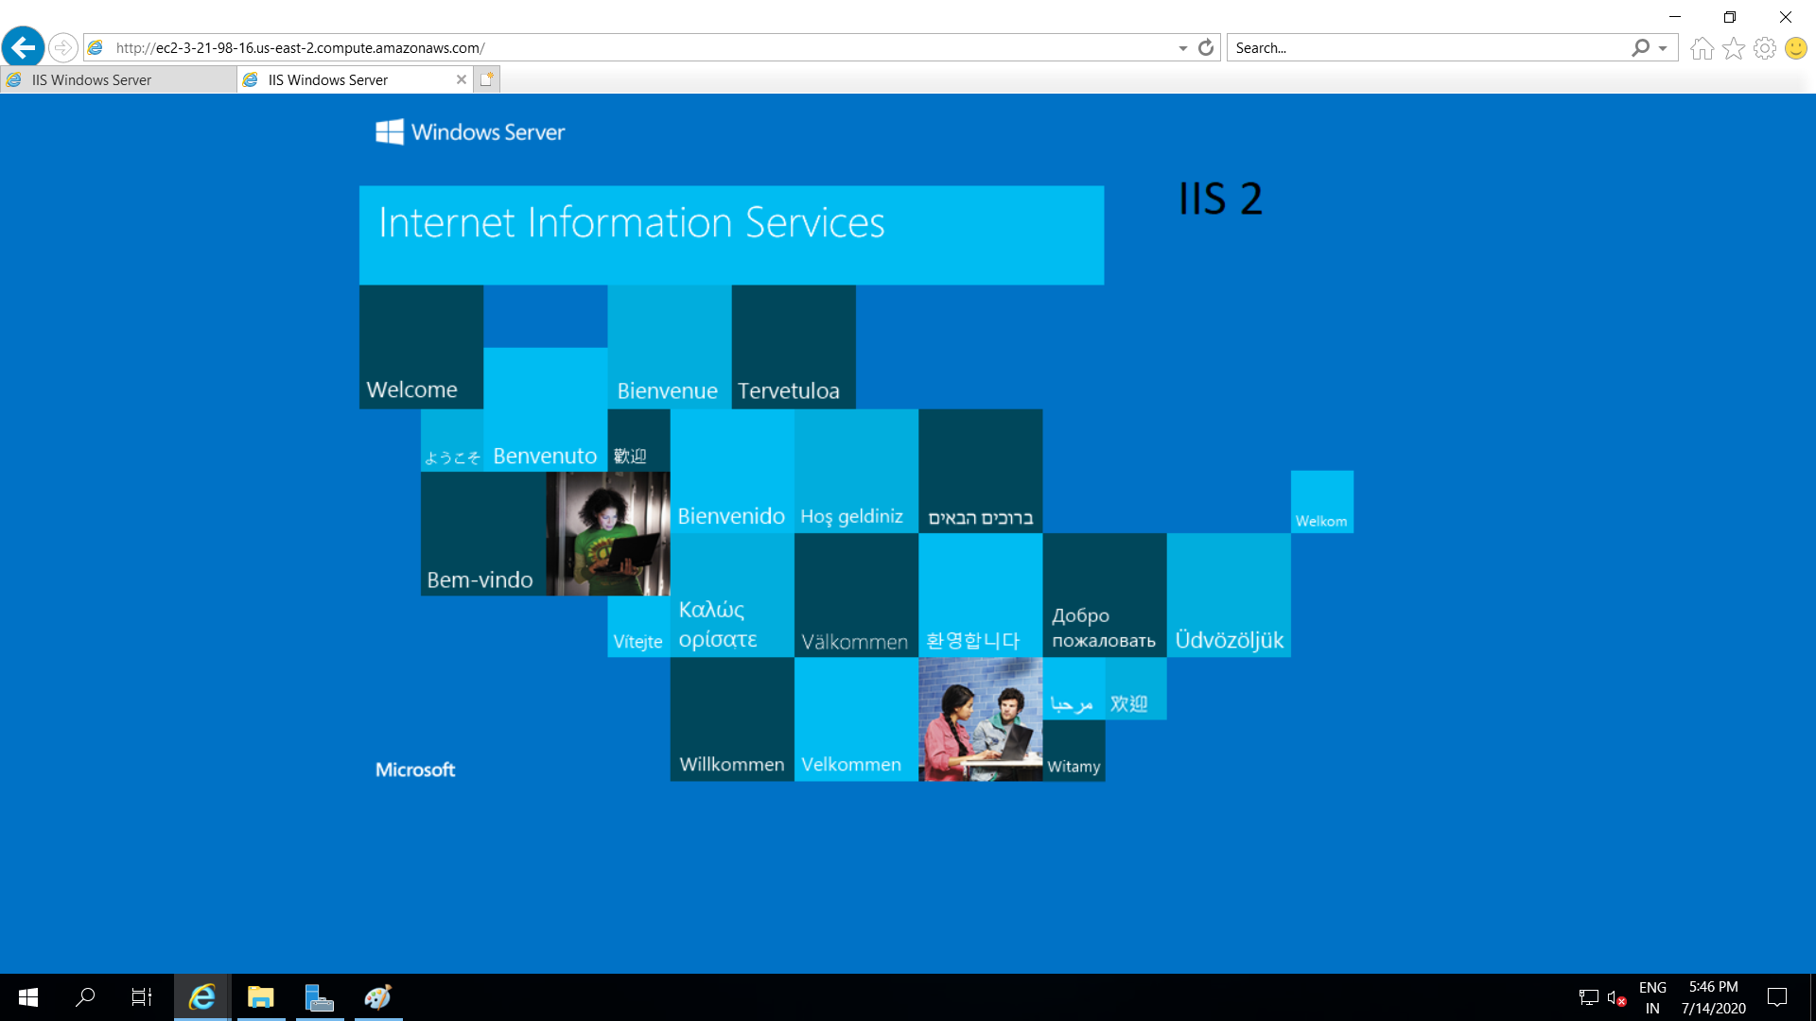

1. Create Load Balancer

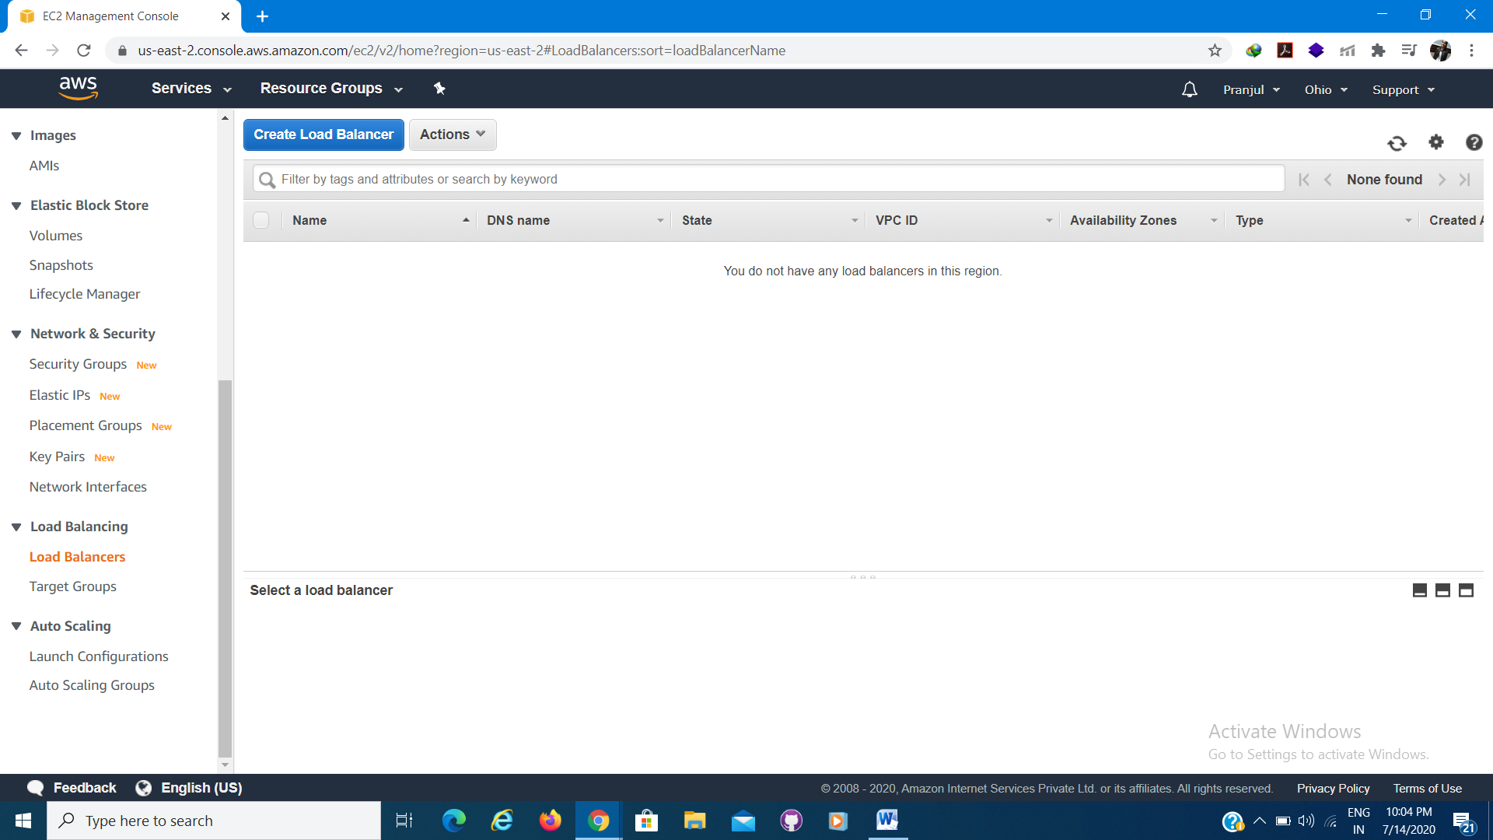

1. Select load balancer type. Configure HTTP service port.

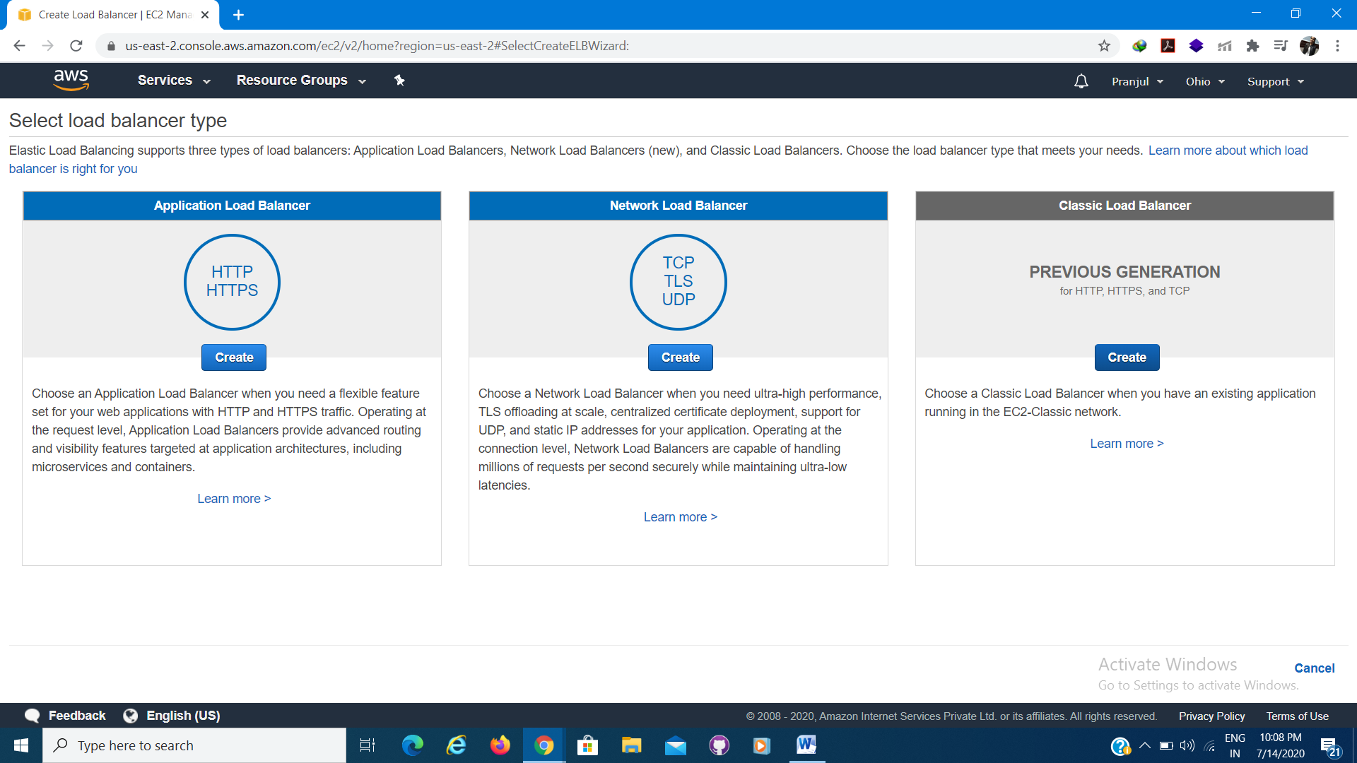

1. Define Load Balancer.

Load Balancer Name: LB1

Enable advanced VPC configuration

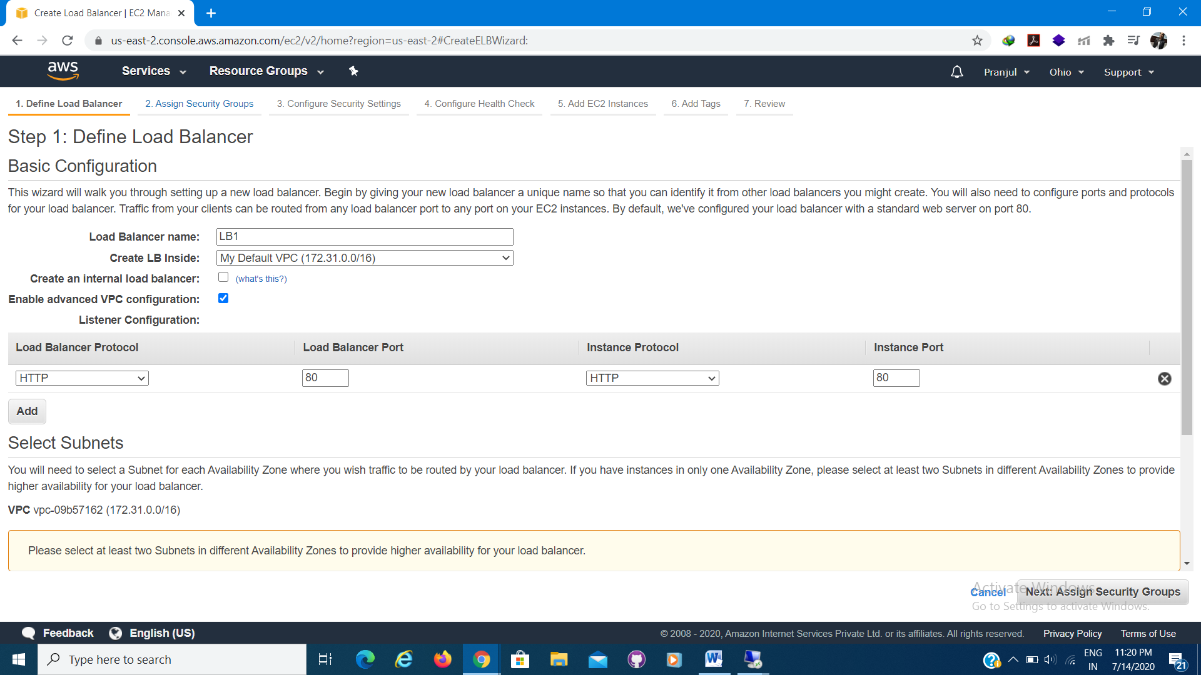

1. Choose sebnets.

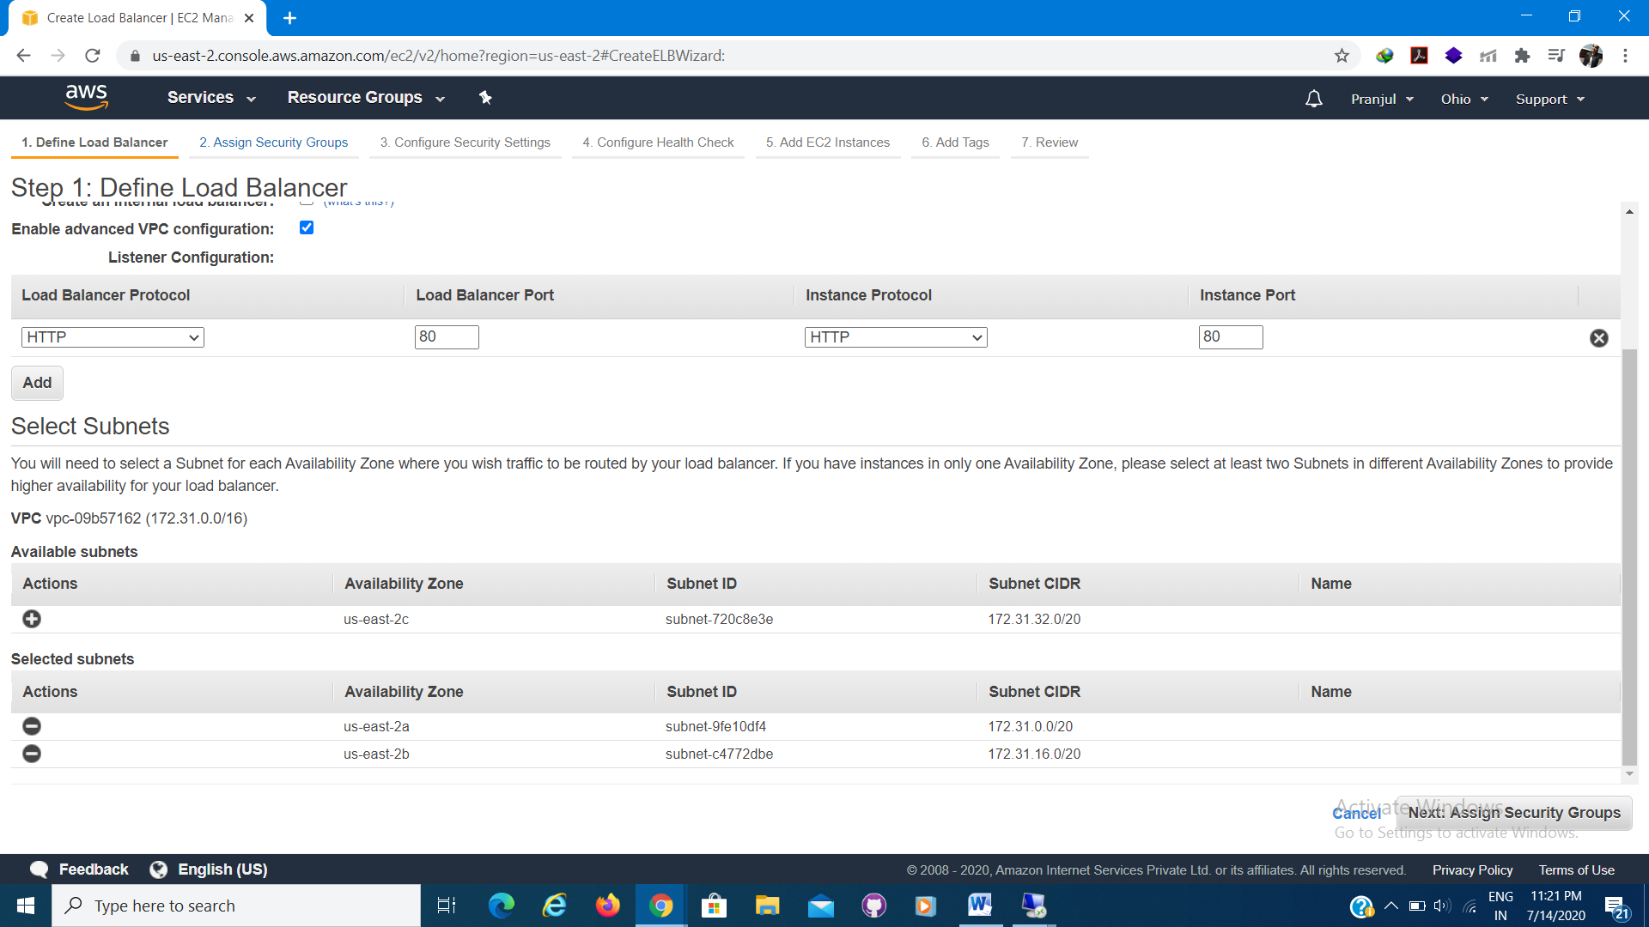

1. Assign Security Groups.

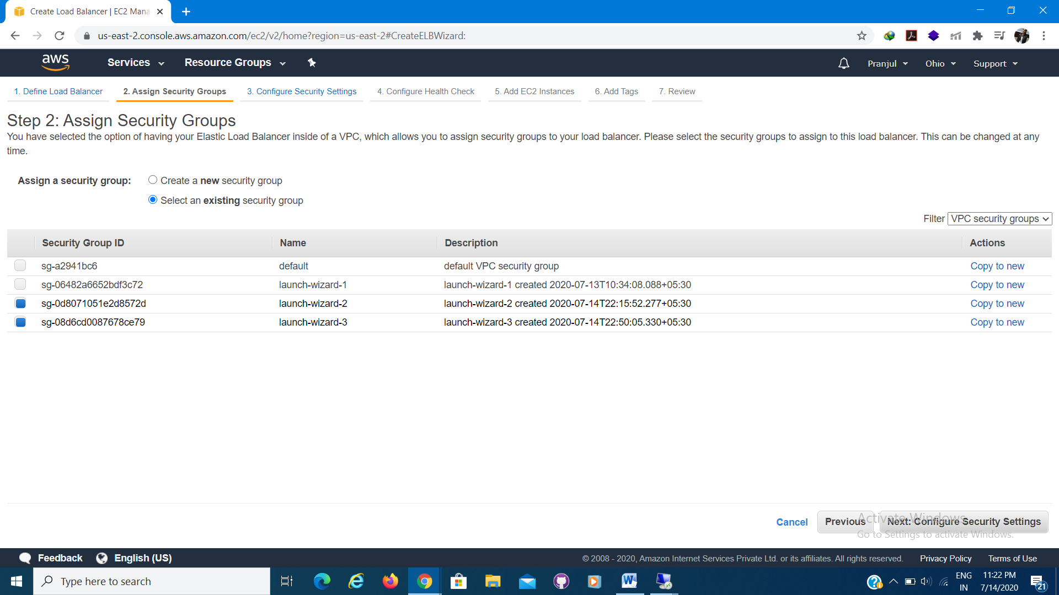

1. Configure Security Settings.

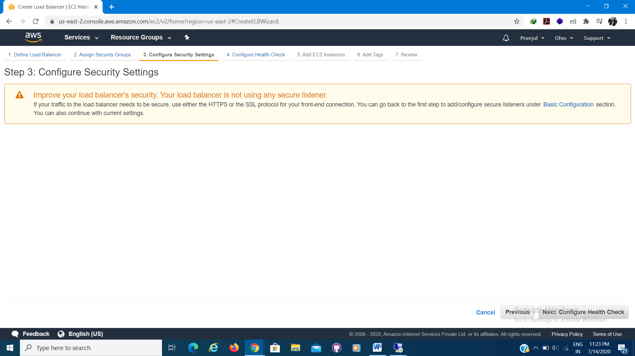

1. Configure Health check.

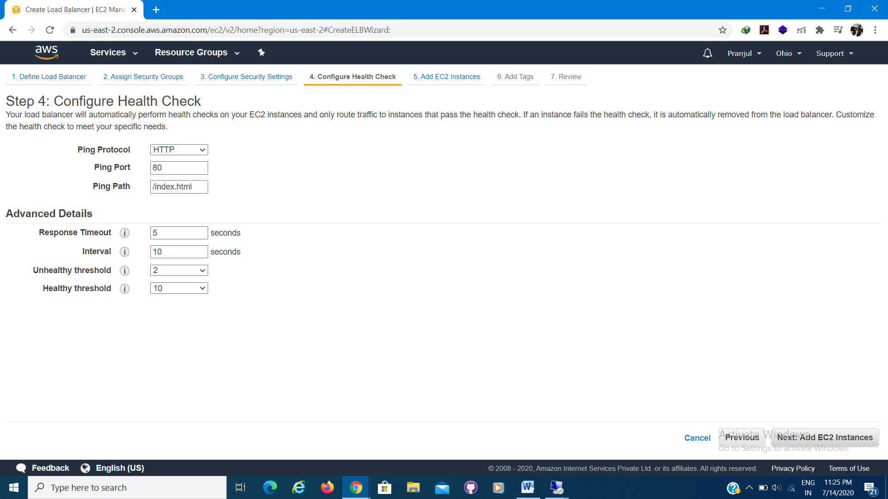

1. Add EC2 Instances

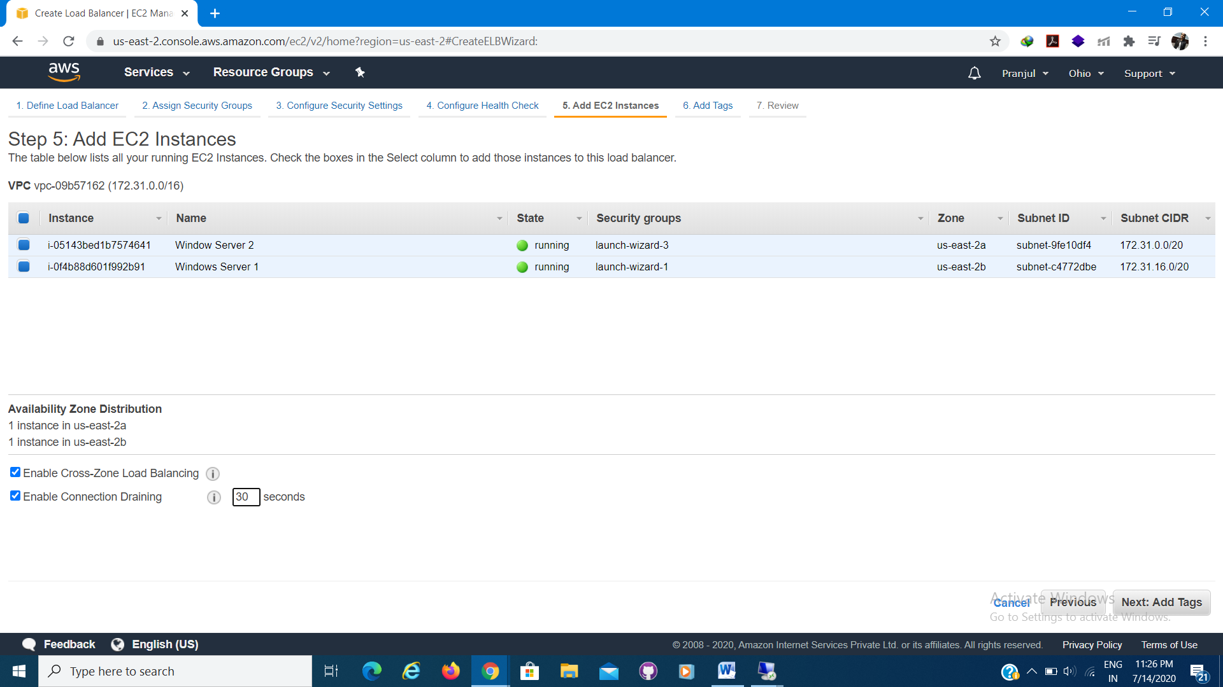

1. Add Tags.

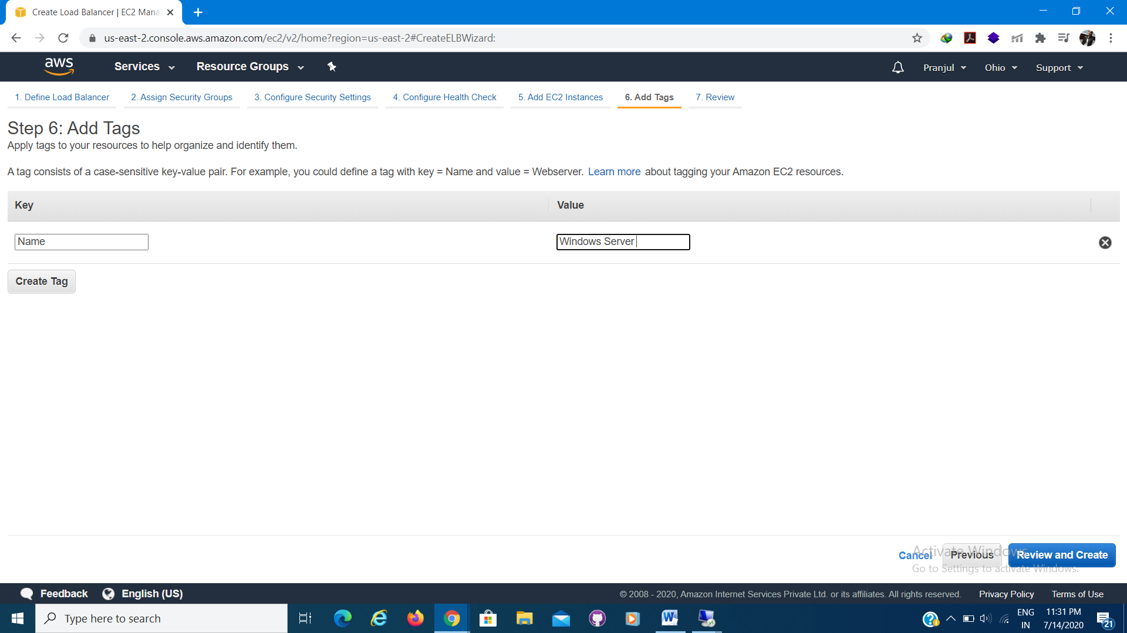

1. Review and create.

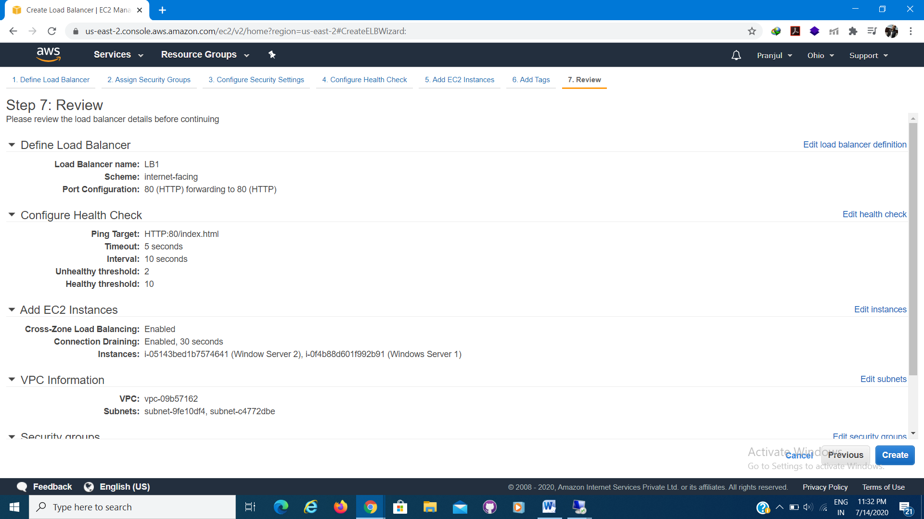

1. Successfully created load balancer.

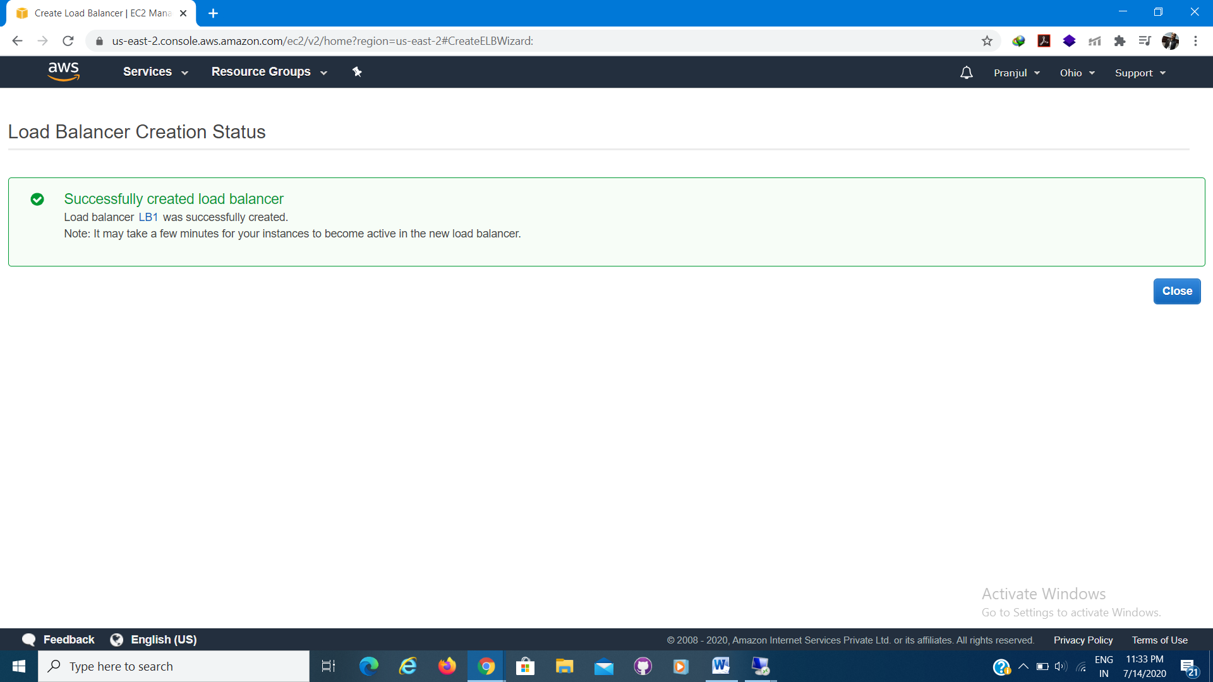

1. Check the status after 30 seconds.

